For submission to *BioScience*

**Increased academic performance and prolonged career duration among Taiwanese academic faculty in ecology and evolutionary biology**

Gen-Chang Hsu1, Wei-Jiun Lin2, Syuan-Jyun Sun3,4*

1Department of Life Science, National Taiwan University, Taipei, Taiwan

2Institute of Ecology and Evolutionary Biology, National Taiwan University, Taipei, Taiwan

3Department of Ecology & Evolutionary Biology, University of Michigan, Ann Arbor, MI 48109, USA

4International Degree Program in Climate Change and Sustainable Development, National Taiwan University, Taipei 10617, Taiwan

*Corresponding author:

sysun@umich.edu

Keywords: academic performance, career duration, faculty, academic job market, publication

**Abstract:**

Academic job markets have become increasingly challenging worldwide, yet it remains poorly characterized how competitively-successful candidates should be and what the underlying determinants of their success are. Focusing on ecology and evolutionary biology, we analyzed the academic performance (measured as h-index) as well as the duration for landing a faculty position and promotion to full professor of 145 principal investigators (PI) over the past 34 years in Taiwan. We found that faculty members had higher performance and longer duration before recruitment as a new PI in recent years. Performance before promotion remained stable, whereas the duration increased over time. The origin and prestige of PhD university had no effect on the performance or duration neither for recruitment nor promotion. Our findings highlight the increasingly crucial role of academic performance, rather than PhD degree itself, in determining academic success.

**Introduction:**

The academic job market has been increasingly competitive in many fields of science, technology, engineering, and mathematics (STEM) (Cyranoski et al. 2011, Ghaffarzadegan et al. 2015, Xue and Larson 2015), with more PhDs produced but vacancies for tenure-track academic positions remaining constant in the past four decades (Schillebeeckx et al. 2013, Larson et al. 2014). For example, in the US, only 7.6% new PhDs in life sciences landed tenure-track positions within three years after graduation in 2010; this surplus of PhD supply has widely expanded to other STEM fields (NSF 2018)

The intensifying competition for tenure-track positions, due to disproportionately high numbers of accumulating applicants per position (Larson et al. 2014), has resulted in higher expectations for academic performance shaped by a “publish or perish” (Garfield 1996). A survey of evolutionary biologists recruited as junior researchers at the National Centre for Scientific Research (CNRS) in France showed that academics recruited in 2013 published nearly twice as many papers as those recruited in 2005 did (Brischoux and Angelier 2015). Although the minimum education requirement for a tenure-track position is having a PhD degree, it has become increasingly frequent for applicants to have one or even more postdoctoral appointments. Consequently, many STEM PhDs work as postdoctoral researchers for a prolonged period and wait for future opportunities until they are competitive enough in the academic job market (Swihart et al. 2016), whereas some turn to alternative careers outside academia. From the CNRS example, Brischoux and Angelier (2015) also showed that the time elapsed between first publication and recruitment had increased from 3.25 to 8 years. The increase in postdoctoral training time can be detrimental to not only the scientific community but also individuals because this increases the age at which researchers become independent, during which the postdocs have to trade off families for research, with fixed-term and relatively low-paying jobs (Acton et al. 2019).

Despite widely claimed that publication expectations and career duration have surged, empirical quantification of the determinants regarding the evolution of academic profiles over time remains understudied. In addition to research productivity, which directly predicts the success of recruitment (van Dijk et al. 2014), the origin and prestige of doctoral-granting institutes have become critical indicators for academic employment (van Dijk et al. 2014), especially in East Asian countries (Shin and Kehm 2013). With the initiative to build world-class universities, many East Asian universities preferentially recruit returnees who obtained PhD degrees from top-ranking universities in Western countries. Hence, competition for limited tenure-track positions is exacerbated when foreign PhDs are favored, leaving domestically-trained PhDs substantially deprived of career development opportunities (Chen 2021). Yet, whether and to what extent publication expectations and career duration differ between domestic and foreign PhDs, and if their academic productivity varies between pre- and post-employment, remain largely unexplored.

In this study, we examined how academic performance as well as the duration for landing tenure-track positions and promotion to full professor changed over time, and their links to PhD university origin, PhD university ranking, and gender. Specifically, we tested the following questions: (1) Is the academic performance for recruitment as a new principal investigator (PI) or promotion to full professor affected by the year of recruitment, PhD university origin, ranking, and gender? (2) Is the duration for recruitment or promotion affected by the year of recruitment, academic performance, PhD university origin, ranking, and gender? (3) Does the academic performance of PIs differ before and after recruitment or promotion? To address these questions, we studied the trend between 1987 and 2021 on 145 faculty members in the field of ecology and evolutionary biology in Taiwan. We aim to provide empirical evidence to illustrate the temporal variations in researchers’ publication performance necessary to secure a faculty position and get a promotion, the role of PhD university origin and prestige as well as gender in determining the success of academic employment, and how these factors contribute to PIs’ future academic performance.

**Materials and Methods:**

1. Data collection

Between November and December, 2021, we surveyed tenure-track faculty members at seven universities in Taiwan, all of which were qualified as research-intensive universities and ranked top 150 in Asia according to 2022 QS Asia University Rankings (<https://www.topuniversities.com/>). We also surveyed academics from Academia Sinica, a leading academic institution in Taiwan. Together, these eight institutes encompassed 34 academic departments/divisions that serve as tenure homes to the field of ecology and evolutionary biology (e.g., ecology, evolution, biodiversity; see Appendix A for details). We excluded researchers in biomedical sciences because publication rates, performance, and collaboration opportunities can vary considerably among these fields (Laurance et al. 2013). Click or tap here to enter text.A total of 145 PIs who had an updated curriculum vitae online (e.g., institutional/personal websites or Open Researcher and Contributor ID [ORCID]) were identified in our survey, with key information on the university and year of PhD completion, the year of recruitment as a new PI, the year of promotion to full professor, and gender, which is well-documented as a key determinant of performance (Witteman et al. 2019). The university ranking was determined based on 2022 QS World University Rankings. The duration for recruitment as a new PI was the time between PhD completion and landing a position; the duration for promotion to full professor was the time between landing a position and getting a promotion.

1. Measurement of academic performance

We collected data on academic performance, measured as h-index (Hirsch 2005), from the Publish or Perish software using Google Scholar data, which is freely available and more transparent for tenure reviews (Pauly and Stergiou 2005). We included peer-reviewed papers and book chapters regardless of authorship for calculation of h-index, while PhD theses and conference presentations were excluded. Although other matrices, such as the number of publications and citations, are also commonly used for measuring academic performance, they were both highly correlated with h-index in our study (publications: *r* = .906, *p* < .001; citations: *r* = .768, *p* < .001), as had also been found in previous studies (Ryan Haley 2012, Laurance et al. 2013). We thus focused on h-index, a widely accepted measure of academic success that incorporates the assessment of quantity (number of papers) and quality (citations) of publications (Glänzel 2006).

We calculated h-index within the five-year interval both before and after the year of recruitment and promotion, generating up to four h-indexes for each PI. We used the duration of five years because it is commonly used by institutes to evaluate the most recent academic performance both for recruiting a new PI and for promotion to full professor. The publications and citations during the year of recruitment and promotion were considered as the performance “before” getting a job and promotion to full professor because these publications, either as published papers or manuscripts “accepted” or “in press”, would most likely contribute to the evaluation of academic performance prior to successful recruitment and promotion. For example, a new PI who started the position in 2010 would have an h-index measured for publications between 2006 and 2010 (i.e., “before” h-index), and another h-index measured for publications between 2011 and 2015 (i.e., “after” h-index). We did not consider “after” h-indexes for PIs who were recruited as a new PI or promoted to full professor less than five years so that all performances had the same duration to compare with.

1. Statistical analysis

*Academic performance before recruitment/promotion.* To examine how various factors affect the academic performance before recruitment as a new PI and promotion to full professor, we fit generalized linear mixed-effects models (GLMMs) with PhD university origin (binary variable: Taiwan vs. Foreign), PhD university ranking, year of recruitment/promotion, gender, and interactions with year as fixed effects, the department nested within university as random effects, and the h-index before recruitment/promotion as the response.

*Duration for recruitment/promotion.* To examine how various factors affect the duration for recruitment and promotion,we fit GLMMs with PhD university origin, PhD university ranking, year of recruitment/promotion, gender, the h-index before recruitment/promotion, and interactions with year as fixed effects, the department nested within university as random effects, and the duration for recruitment/promotion as the response.

*Changes in academic performance before and after recruitment/promotion.* To compare the academic performance before and after recruitment and promotion, we fit GLMMs with PhD university origin, PhD university ranking, year of recruitment/promotion, gender, and interactions with year as fixed effects, the department nested within university as random effects, and the difference in h-index before and after recruitment/promotion (i.e., “after” h-index – “before” h-index) as the response.

GLMMs were performed using the package “lme4” (Bates et al. 2015); post-hoc pairwise comparisons were performed using the package “emmeans” (Lenth 2021). Response variables (h-index and duration for recruitment/promotion) were log-transformed prior to analyses to meet the assumption of normality. The assumption of independence and equal variance were both assessed using the residual plots. Non-significant interactions (*p* > .05) were dropped from our final model results. All analyses were performed in R version 4.1.2 (R Development Core Team 2014).

**Results:**

In total, we collected data on145 tenure-track faculty members, of which 44.8% were full professors, 24.8% were associate professors, and 30.3% were assistant professors. The gender difference was substantial, with males (112) around four times as prevalent as females (33). The universities from which the PIs obtained their PhD degrees varied widely in the ranking of prestige among 73 universities from 16 countries (figure S1, figure S2). Nearly half of the PIs obtained their degrees from the USA (45.5%), followed by Taiwan (33.1%), and relatively few from the UK (4.8%) and other countries.

Faculty members who landed tenure-track positions more recently had higher academic performance (h-index) before recruitment, whereas PIs performed equally well before promotion to full professor irrespective of time (table 1, figure 1a–1b). Although males had on average higher performance than females before recruitment, no such gender difference was found before promotion. PhD university origin and ranking had no effect on the performance either before recruitment or before promotion (table 1).

Faculty members who landed positions more recently spent more time post-PhD before recruitment, but higher academic performance reduced this duration (table 1, figure 1c). On the other hand, PIs also spent more time before promotion to full professor in recent years, yet the duration was not affected by the academic performance (table 1, figure 1d). PhD university origin, ranking, and gender had no effect on the duration for either recruitment or promotion (table 1).

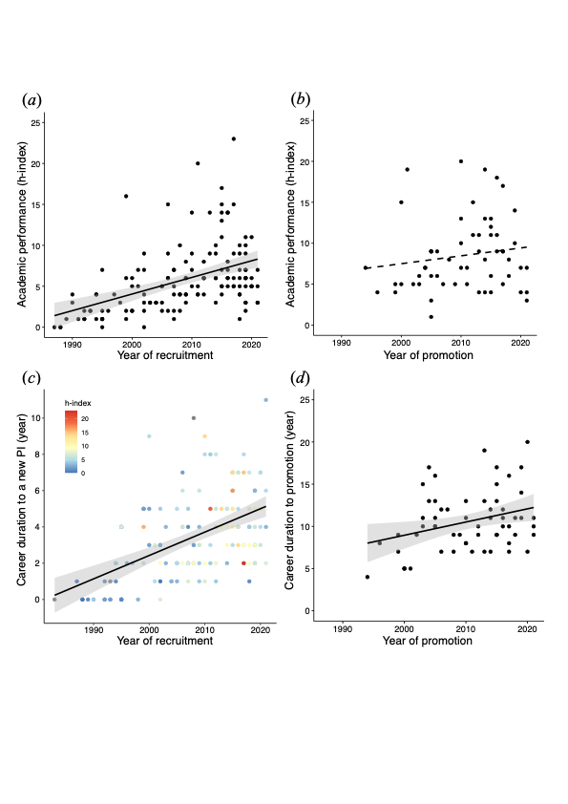

Figure 1. Temporal variations in academic performance (*a & b*) and career duration (*c & d*) for recruitment and promotion. Each point represents an individual PI, with points in (*c*) colored by h-index. Solid/dashed lines represent significant/non-significant relationships predicted from GLMMs; shaded areas indicate 95% confidence intervals.

The difference in academic performance before and after recruitment (“after” h-index – “before” h-index) decreased for PIs who landed positions more recently, while PhD university origin, ranking, and gender had no effect on the performance difference (table 1, figure 2a–2b). In contrast, the performance difference before and after promotion to full professor was not affected by the year of promotion, PhD university ranking, or gender, yet the difference tended to be higher for PIs with foreign degrees compared to those with Taiwanese degrees (table 1, figure 2c–2d).

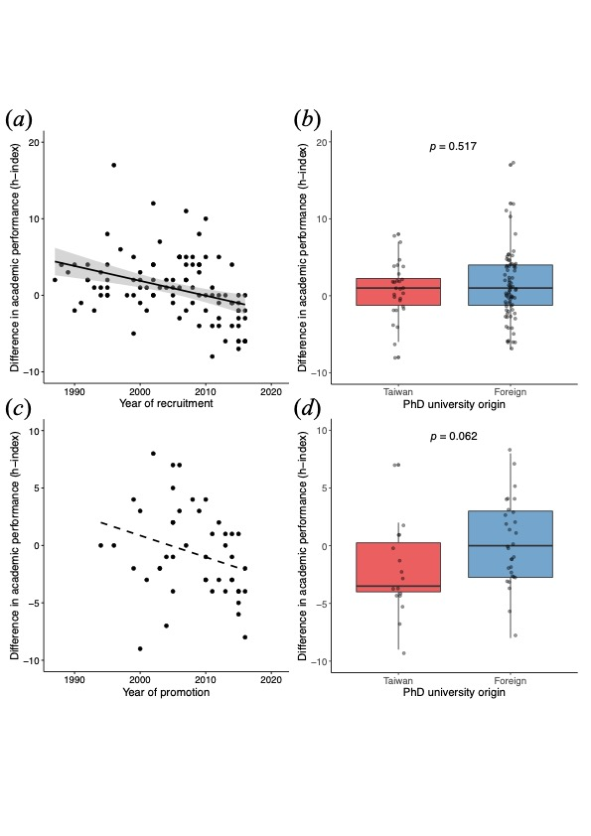

Figure 2. Difference in academic performance before and after (“after” h-index – “before” h-index) recruitment as a new PI (*a & b*) and promotion to full professor (*c & d*) in relation to year of recruitment/promotion and PhD university origin. Each point represents an individual PI. Solid/dashed line represents significant/non-significant relationship predicted from GLMMs; shaded areas indicate 95% confidence intervals.

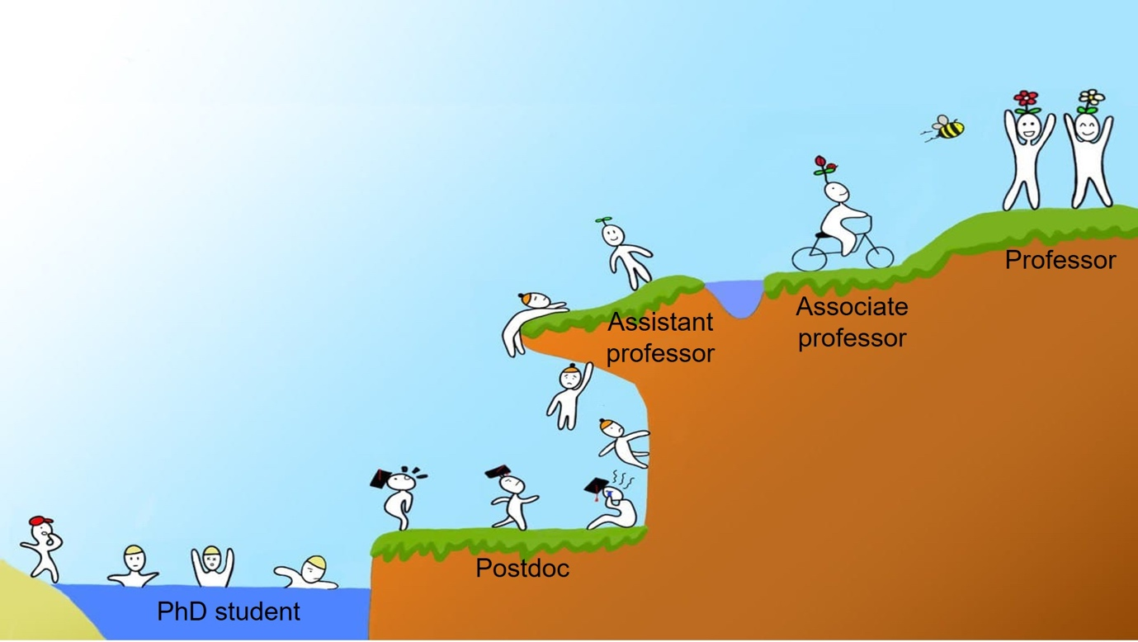

Figure 3. An increasingly challenging pathway for academic success.

**Discussion:**

Overall, we showed that the academic performance of PIs before landing faculty positions increased over years, whereas the performance before promotion to full professor remained relatively unchanged. We also found that the duration for both recruitment and promotion increased in recent years. These results provide empirical evidence supporting the suspicion that publication requirements and expectations have risen over time in ecology and evolution in Taiwan, in line with many academic job markets worldwide (Rawat and Meena 2014, Warren 2019; figure 3).

The increase in academic performance of PIs before recruitment suggests that the academic job market has become increasingly competitive over time, which is likely driven by a relatively lower demand for tenure-track professors compared to the supply of new PhDs (Larson et al. 2014). Consequently, the duration post-PhD would be prolonged if the applicants are not competitive enough. However, higher academic performance could help shorten the time to land a position. Therefore, early-career researchers should focus on their publications to demonstrate the competence for academic success. On the other hand, the academic performance of PIs before promotion remained similar over years, suggesting that the requirements for promotion might not have changed much over time. Interestingly, the time to full professor has lengthened in recent years but was not affected by academic performance, possibly due to increasing consideration of accomplishments such as teaching and administrative services by employment institutes in addition to research outputs. The different patterns in academic performance and career duration between recruitment and promotion phase are likely because applicants face increasing competition with others during recruitment and higher performance would be advantageous for securing a position, whereas getting a promotion depends mainly on meeting the institutes’ requirements rather than comparing with others’ performance.

We found that the average performance of a new male PI was higher than that of a new female PI, indicating that the standards for evaluating the suitability of a potential faculty member might be higher for males than females (Symonds et al. 2006). But after recruitment, the performance expectations for promotion to full professor did not differ between male and female PIs. In contrast to a previous study (van Dijk et al. 2014), we found no evidence of PhD university origin and ranking influencing the career duration for either recruitment or promotion. Instead, academic performance during PhD and/or post-PhD period is more important in determining the academic success compared with the prestige of education itself.

The difference in performance before and after recruitment decreased over years. Earlier PIs had on average higher h-indexes after recruitment compared with before recruitment, yet such a “performance boost” has declined in recent years. This could be due to increasing teaching and administrative demands of new PIs, reducing the time available for research. Strikingly, we found that PIs performed consistently before and after recruitment regardless of PhD university origin or ranking. However, PIs with PhD degrees in Taiwan showed a decrease in performance after promotion to full professor, whereas those with foreign PhD degrees had relatively consistent performance. One possible explanation is that the training and experiences from foreign universities may have equipped those PIs with greater professional abilities, which together with international connections and collaboration opportunities, helps maintain their performance.

Our findings were based mainly on PIs in ecology and evolutionary biology. Since the nature of academic job markets can vary considerably among different fields of biology (Larson et al. 2014), the results should be interpreted carefully when applied to the fields outside the scope of this study. Nonetheless, our findings confirm that succeeding in academia has become more challenging, with publication requirements and career duration both increasing over time. In the face of increasingly competitive academic job markets, boosting performance is the key to career success in academia.

**Authors’ contributions:**

G.-C.H. and S.-J.S. conceived the study; W.-J.L. and S.-J.S. collected the data; G.-C.H. and S.-J.S. analyzed the data. All authors were involved in writing the manuscript.

**Competing interests:**

The authors declare no competing interests.

**Funding:**

No funding was received for conducting this study.

**Acknowledgement:**

We thank Ming-Yang Megan Chang for constructive discussion and comments.

**References:**

Acton SE, Bell AJ, Toseland CP, Twelvetrees A. 2019. A survey of new PIs in the UK. eLife 8.

Bates D, Maechler M, Bolker B, Walker S. 2015. Fitting linear mixed-effects models using lme4. R package version.

Brischoux F, Angelier F. 2015. Academia’s never-ending selection for productivity. Scientometrics 103: 333–336.

Chen N. 2021. “Why should a ‘foreigner’ be better than me?”: preferential practices in junior academic faculty recruitment among mainland Chinese universities. Tertiary Education and Management 1–25.

Cyranoski D, Gilbert N, Ledford H, Nayar A, Yahia M. 2011. Education: The PhD factory. Nature 472: 276–279.

van Dijk D, Manor O, Carey LB. 2014. Publication metrics and success on the academic job market. Current biology : CB 24.

Garfield E. 1996. What Is The Primordial Reference For The Phrase “Publish Or Perish”? The Scientist 10: 11.

Ghaffarzadegan N, Hawley J, Larson R, Xue Y. 2015. A Note on PhD Population Growth in Biomedical Sciences. Systems Research and Behavioral Science 32: 402–405.

Glänzel W. 2006. On the h-index - A mathematical approach to a new measure of publication activity and citation impact. Scientometrics 2006 67:2 67: 315–321.

Hirsch JE. 2005. An index to quantify an individual’s scientific research output. Proceedings of the National Academy of Sciences 102: 16569–16572.

Larson RC, Ghaffarzadegan N, Xue Y. 2014. Too many PhD graduates or too few academic job openings: The basic reproductive number R0 in academia. Systems Research and Behavioral Science 31: 745–750.

Laurance WF, Useche DC, Laurance SG, Bradshaw CJA. 2013. Predicting Publication Success for Biologists. BioScience 63: 817–823.

Lenth R v. 2021. emmeans: Estimated marginal means, aka least-squares means. R package version 1.7.1. R Foundation for Statistical Computing 34: 216–221.

[NSF] National Science Foundation. 2018. Science and Engineering Indicators. NSB-2018-1. (February 6, 2022; https://www.nsf.gov/statistics/seind/).

Pauly D, Stergiou KI. 2005. Equivalence of results from two citation analyses: Thomson ISI’s Citation Index and Google’s Scholar service. undefined 5: 33–35.

R Development Core Team. 2014. R: A language and environment for statistical computing. R Foundation for Statistical Computing.

Rawat S, Meena S. 2014. Publish or perish: Where are we heading? Journal of Research in Medical Sciences : The Official Journal of Isfahan University of Medical Sciences 19: 87.

Ryan Haley M. 2012. Rank variability of the Publish or Perish metrics for economics and finance journals. http://dx.doi.org/10.1080/13504851.2012.697115 20: 830–836.

Schillebeeckx M, Maricque B, Lewis C. 2013. The missing piece to changing the university culture. Nature Biotechnology 2013 31:10 31: 938–941.

Shin JC, Kehm BM. 2013. Institutionalization of world-class university in global competition. Institutionalization of World-Class University in Global Competition 1–301.

Swihart RK, Sundaram M, Höök TO, Dewoody JA. 2016. Factors affecting scholarly performance by wildlife and fisheries faculty. The Journal of Wildlife Management 80: 563–572.

Symonds MRE, Gemmell NJ, Braisher TL, Gorringe KL, Elgar MA. 2006. Gender Differences in Publication Output: Towards an Unbiased Metric of Research Performance. PLOS ONE 1: e127.

Warren JR. 2019. How much do you have to publish to get a job in a top sociology department? Or to get tenure? Trends over a generation. Sociological Science 6: 172–196.

Witteman HO, Hendricks M, Straus S, Tannenbaum C. 2019. Are gender gaps due to evaluations of the applicant or the science? A natural experiment at a national funding agency. The Lancet 393: 531–540.

Xue Y, Larson RC. 2015. STEM crisis or STEM surplus? Yes and yes. Monthly labor review 2015.

**Supplementary information:**



Figure S1. Distribution of the universities from which the 145 PIs obtained their PhD degrees. Percentages of PhD degrees obtained from the USA, Taiwan, and the UK are as noted, whereas “other” includes those less than 4%.

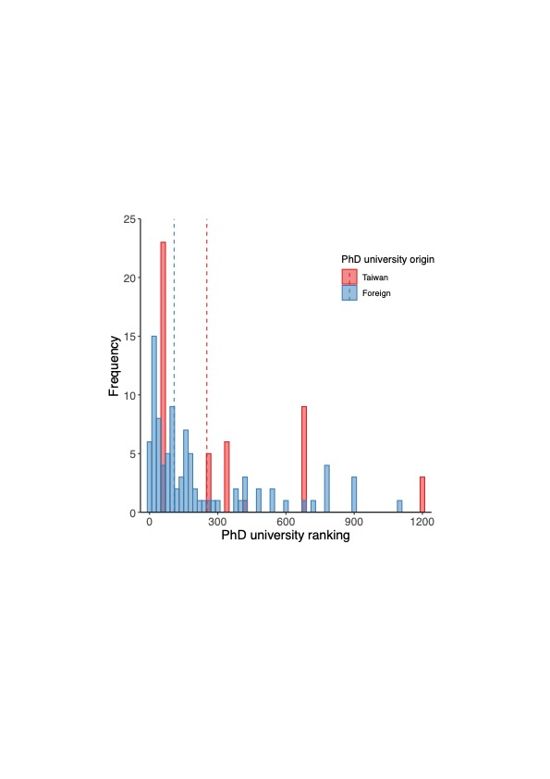

Figure S2. Distribution of the ranking of universities from which PIs obtained their PhD degrees. Dashed lines indicate medians of university ranking for Taiwanese (252) and foreign (108) PhD degrees.

|  |  |  |  |  |
| --- | --- | --- | --- | --- |
| Table 1. Results of the GLMMs (type III sum of squares) for analyzing academic performance, career duration, and difference in performance before and after recruitment as a new PI and promotion to full professor. | | | | |
| **Response** | **Predictor** | ***χ²*** | **d.f.** | ***p*** |
| Academic performance (new PI) | PhD university origin | 1.42 | 1 | .234 |
|  | PhD university ranking | 0.45 | 1 | .503 |
|  | Year of recruitment | 74.68 | 1 | **< .001** |
|  | Gender | 5.73 | 1 | **.017** |
| Academic performance (promotion) | PhD university origin | 0.06 | 1 | .812 |
|  | PhD university ranking | 1.06 | 1 | .304 |
|  | Year of promotion | 0.97 | 1 | .324 |
|  | Gender | 0.07 | 1 | .791 |
| Duration (new PI) | Academic performance | 6.10 | 1 | **.014** |
|  | PhD university origin | 1.01 | 1 | .315 |
|  | PhD university ranking | 1.82 | 1 | .178 |
|  | Year of recruitment | 43.08 | 1 | **< .001** |
|  | Gender | 0.78 | 1 | .377 |
|  | Academic performance x Year of recruitment | 6.06 | 1 | **.014** |
| Duration (promotion) | Academic performance | 1.87 | 1 | .171 |
|  | PhD university origin | 1.96 | 1 | .161 |
|  | PhD university ranking | 0.62 | 1 | .430 |
|  | Year of promotion | 7.03 | 1 | **.008** |
|  | Gender | 3.18 | 1 | .075 |
| Difference in performance (new PI) | PhD university origin | 0.42 | 1 | .517 |
|  | PhD university ranking | 0.38 | 1 | .537 |
|  | Year of recruitment | 15.40 | 1 | **< .001** |
|  | Gender | 0.06 | 1 | .800 |
| Difference in performance (promotion) | PhD university origin | 3.48 | 1 | .062 |
|  | PhD university ranking | 0.51 | 1 | .474 |
|  | Year of promotion | 2.96 | 1 | .086 |
|  | Gender | 0.81 | 1 | .369 |
| *p* values < .05 are highlighted in bold |  |  |  |  |